Galapagos Northeast Discovery and Diversity
Itinerary C / 6 Days – 5 Nights

 |  |  |  | HIKING | SNORKEL | PANGA RIDE | PADDLE  BOARD | KAYAK
6 DAYS "C" | MONDAY | PM | Seymour: North Seymour | •
6 DAYS "C" | TUESDAY | AM | Bartolome: Bartolome | • | • | •
6 DAYS "C" | TUESDAY | PM | Santiago: Sullivan Bay | • | •
6 DAYS "C" | WEDNESDAY | AM | Genovesa: Darwin Bay | • | • | • | • | •
6 DAYS "C" | WEDNESDAY | PM | Genovesa: El Barranco | • | • | • | • | •
6 DAYS "C" | THURSDAY | AM | Plazas: South Plazas | • | •
6 DAYS "C" | THURSDAY | PM | Santa Fe Island | • | • | • | • | •
6 DAYS "C" | FRIDAY | AM | San Cristobal: Highlands | •
6 DAYS "C" | FRIDAY | PM | San Cristobal: Lobos Island | • | • | •
6 DAYS "C" | SATURDAY | AM | San Cristóbal: Kicker Rock
Day 1 – Monday
AM: BALTRA AIRPORT
Departure to the Galapagos Islands, arrive at Baltra airport, where a National Park-certified naturalist guide will warmly welcome you to this biodiversity-rich paradise. Your exciting journey in the footsteps of Darwin is about to start!
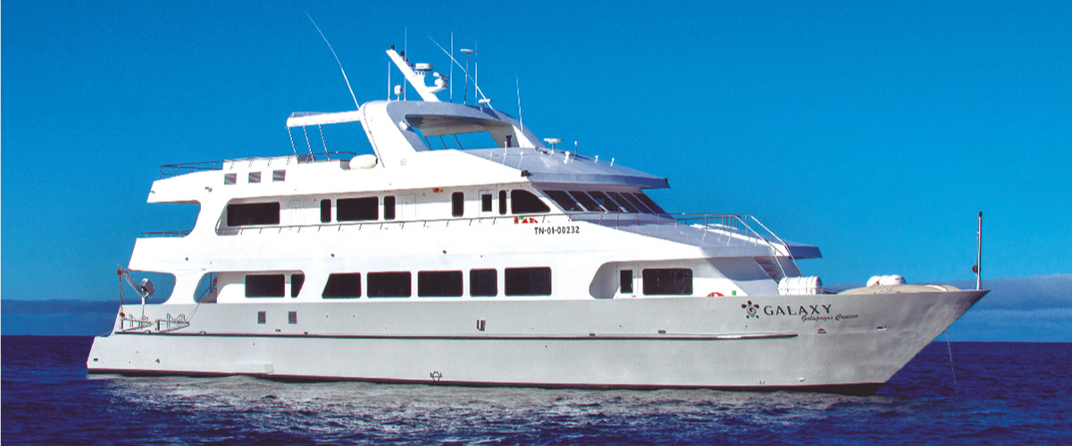

PM – NORTH SEYMOUR & TRANSFER OUT TO BALTRA’S AIRPORT
Your journey continues with a morning visit to North Seymour Island, a spectacular showcase of the Galapagos Islands' diverse wildlife. This relatively flat island is home to a thriving population of blue-footed boobies and frigate birds. The trail winds its way through a forest of low, bushy vegetation, where you'll have the opportunity to witness the fascinating courtship dance of the blue-footed boobies. The island's coastline also allows one to observe sea lions and marine iguanas basking in the sun. The large frigate bird colonies are a sight, especially when the males inflate their bright red throat pouches to attract mates.
Birdwatching Experience: Encounter the majestic frigate birds and charming blue-footed boobies in their natural habitat. This is an ideal spot for birdwatching and photography.
Highlights: Blue-footed boobies, frigate birds, sea lions, marine iguanas.
Meals | B / L / D
Trail | 2 km
Level | 2
Activities | Dry landing, hiking

Day 2 – Tuesday
AM: BARTOLOME
Bartolome Island is one of the most iconic places in the Galapagos, renowned for its accessible penguin population and the beautiful Pinnacle Rock. The beach nearby the rock is painted with peach-colored sand, adding to the surreal beauty of the landscape. A hike to the island's summit will offer you panoramic views of lunar-like landscapes dotted with volcanic cones, numerous islands, Sullivan Bay, and, of course, the towering Pinnacle Rock.
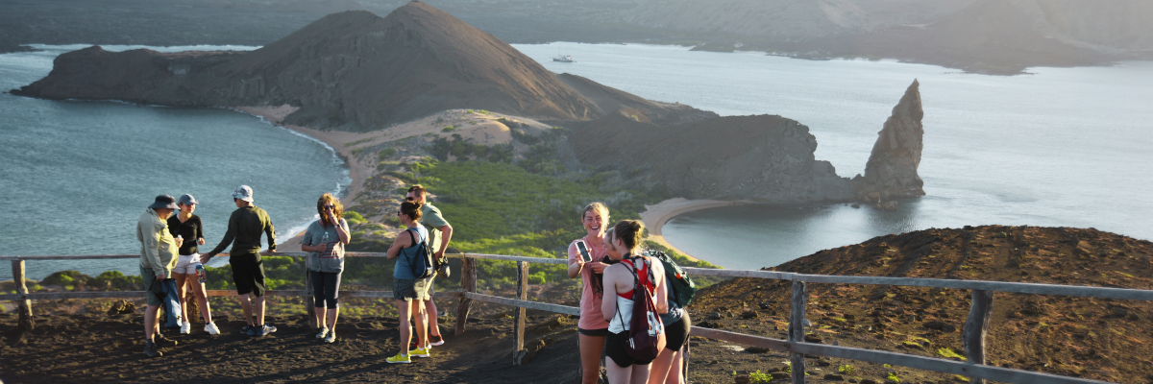
Snorkeling Experience: Following the hike, you have the option to swim or snorkel from the beach. This location boasts a well-deserved reputation as one of the best snorkeling spots in the Galapagos, with its clear, calm water and diverse underwater life. This includes penguins, which are surprisingly easy to spot, along with many colorful fish, invertebrates, playful sea lions, turtles, rays, and reef sharks.
Highlights: Galapagos penguins, volcanic landscapes, Pinnacle rock, blue-footed boobies, herons, sea lions, and sharks.
Trail | 1,5 km / 0,9 mi
Level | 2
Activities | Dry landing and hiking

PM: SULLIVAN BAY
Walking through Sullivan Bay offers an extraordinary journey into the volcanic origins of the Galapagos Islands. Your hike will take you across a perfectly preserved Pahoehoe lava flow, providing endless opportunities to observe the delicate textures of this rare type of lava. While the landscape may appear barren and lifeless at first, a closer look reveals resilient pioneer plants, scurrying lava lizards, and small birds. Along the shore, penguins, pelicans, and oystercatchers add a touch of life to the stark environment.
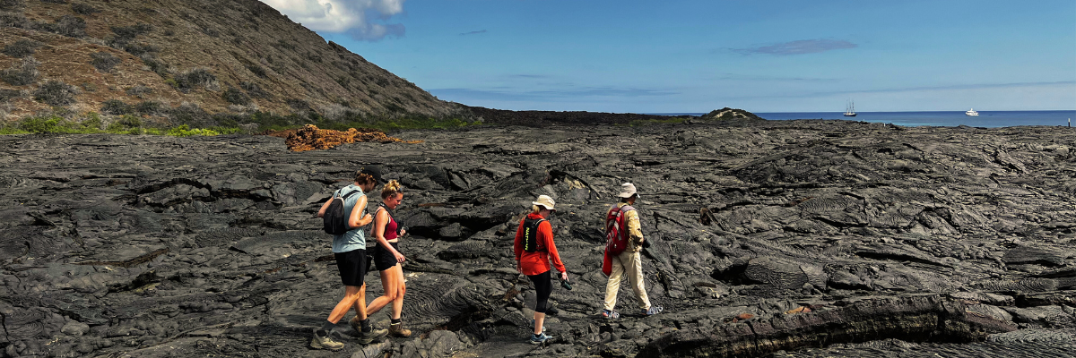
Snorkeling Experience: Following the hike, you can swim or snorkel from a coral sand beach or the dinghies. The underwater world here starkly contrasts the sparse land, teeming with schools of fish, Galapagos penguins, reef sharks, turtles, and rays.
Highlights: Pahoehoe lava, Galapagos penguins, oystercatchers, Galapagos hawks.
Meals | B / L / D
Trail | 2,2 km / 1,4 mi
Level | 3
Activities | Dry landing and hiking

Day 3 – Wednesday
AM: DARWIN BAY
Darwin Bay on Genovesa Island is a birder's dream come true. When you set foot on the beach, you will be amazed by the spectacle of hundreds of boobies, gulls, and frigatebirds soaring above, nesting in the bushes, or roosting on the sandy terrain. This immersive wildlife trail hosts sea lions and marine iguanas by the sea, and inland you'll encounter night herons, lava and swallow-tailed gulls, Darwin finches, Galapagos doves, mockingbirds, and more.
Snorkeling Experience: Darwin Bay offers a variety of snorkeling locations, from deep waters along the bay's cliffs to shallow waters near the beach. Regardless of where you choose, a colorful variety of fish awaits your visit, with a high chance of spotting sharks, rays, and sea lions.

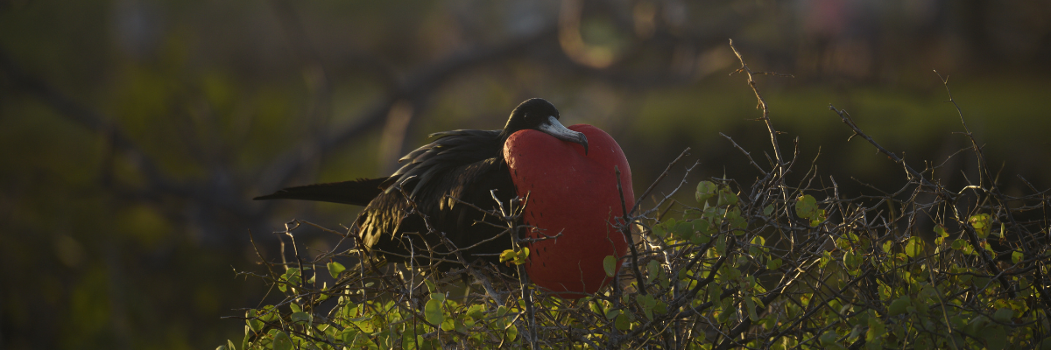
Highlights: Nesting great frigatebirds, red-footed & Nazca boobies, Galapagos sea lions, lava & swallow-tailed gulls, yellow-crown night herons, Genovesa ground finch, Genovesa cactus finch, Galapagos mockingbirds.
Trail | 1,2 km / 0,7 mi
Level | 3
Activities | Wet landing and hiking

PM: EL BARRANCO
Located in the southern part of Darwin Bay on Genovesa Island, El Barranco is blessed with cliffs facing the sea made from very fragile, fractured lava. This creates an ideal nesting environment for storm petrels, attracting a significant population of short-eared owls. The trail is dotted with red-footed and Nazca boobies. At the same time, the base of the cliffs provides restful, shaded areas for Galapagos fur seals and numerous seabirds.
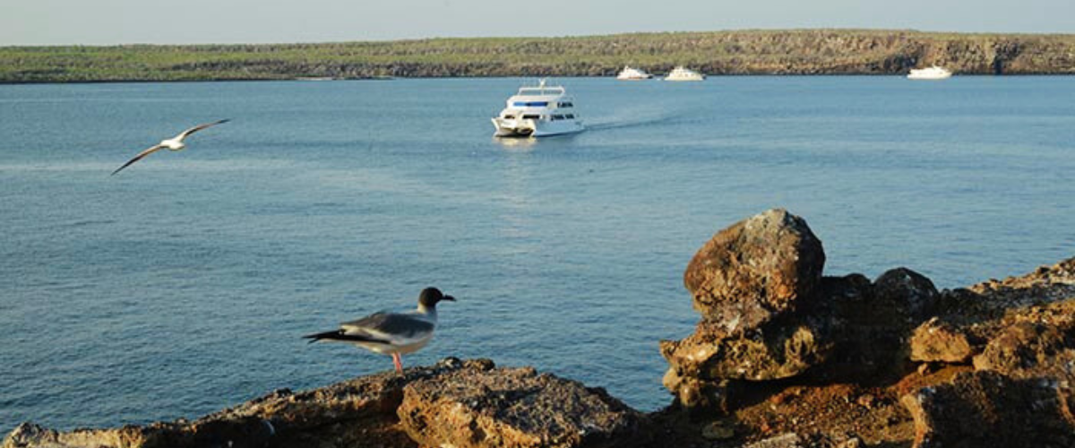
Snorkeling Experience: Snorkeling alongside these cliffs is an exhilarating experience, teeming with diverse fish and providing great chances to see sharks, rays, and playful sea lions.
Highlights: Nesting great frigatebirds, red-footed & Nazca boobies, Galapagos sea lions, Galapagos fur seals, lava & swallow-tailed gulls, yellow-crown night herons, Genovesa ground finch, Genovesa cactus finch, Galapagos mockingbirds.
Trail | 1,2 km / 0,7 mi
Level | 3
Activities | Wet landing and hiking

Day 4 – Thursday
AM: SOUTH PLAZAS ISLAND
Begin your day with a visit to South Plazas Island, one of the smaller yet vibrant islands in the Galapagos. This island is renowned for its extraordinary flora, including towering cacti and the striking Sesuvium plant, which changes from green to bright red during the dry season. South Plazas is also home to a large colony of land iguanas, which are often seen lounging under the cacti or wandering around. The steep cliffs on the southern part of the island provide a haven for various seabirds, including swallow-tailed gulls and red-billed tropicbirds. Sea lions frequent the coastline and offers an excellent opportunity to observe their playful antics in the water.
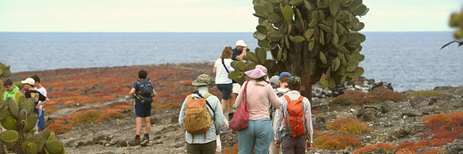
Highlights: Land iguanas, Sesuvium plants, cacti, sea lions, swallow-tailed gulls, red-billed tropicbirds.
Trail | 1 km / 0.6 mi
Level | 2
Activities | Dry landing, hiking

PM: SANTA FE ISLAND
In the afternoon, set off to explore Santa Fe Island, known for its picturesque bay and turquoise waters, perfect for swimming and snorkeling. The island hosts a healthy population of the larger species of land iguanas unique to Santa Fe. Watch for these magnificent creatures as you walk through the giant prickly pear cactus forest. The island's calm, clear waters are ideal for spotting an array of marine life, including sea turtles, rays, and colorful schools of fish. Santa Fe also offers a chance to see the Galapagos hawk and various endemic finches.
This day offers a blend of terrestrial and marine exploration, showcasing the diverse landscapes and wildlife the Galapagos Islands are famous for.

Highlights: Santa Fe land iguanas, prickly pear cactus, sea turtles, Galapagos hawk, snorkeling opportunities.
Meals | B / L / D
Trail | 1.5 km / 0.9 mi
Level | 2
Activities | Wet landing, hiking, snorkeling

Day 5 – Friday
AM: Highlands
Your day begins with a journey to the highlands of San Cristobal Island, offering a different perspective of the Galapagos' unique ecosystem. This lush and verdant area contrasts sharply with the coastal zones. The highlands are home to a variety of bird species, giant tortoises in their natural habitat, and a rich array of plant life, including endemic trees and ferns. You'll have the opportunity to walk along paths that meander through this lush landscape, offering a chance to observe the giant tortoises up close and personal. The highlands also provide panoramic views of the island, showcasing its diverse topography.
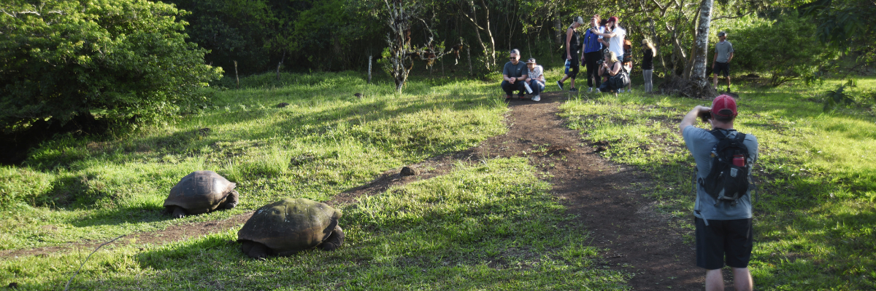
Highlights: Giant tortoises, endemic bird species, panoramic views, lush vegetation.
Meals | B/L/D
Trail | Variable
Level | 2
Activities | Dry landing and hiking

PM: LOBOS ISLAND
Venture to Lobos Island, a tranquil islet secluded from San Cristobal by a slim channel. This nature's cradle, amidst a serene bay, is the playground for sea lion pups frolicking in tidal pools. The island might be modest but bursts with life, particularly with "lobos marinos" or sea lions. As you step ashore, welcoming committees of sea lions would greet you, only to be outraged by the male frigatebirds inland, presenting their inflamed red balloons amidst the verdant foliage. Stay vigilant for the blue-footed boobies nesting on the trails, ready to treat you to a display of their whimsical courtship dance.
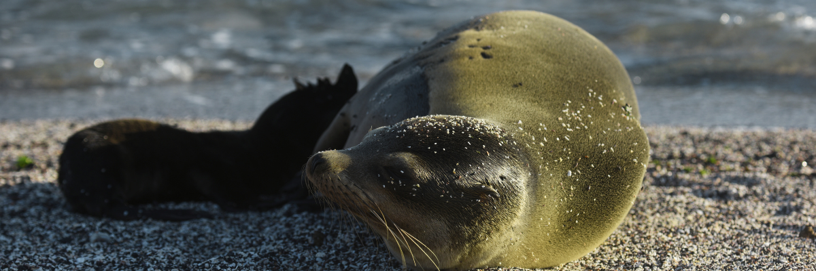
Snorkeling Experience: Dive into an underwater ballet at this renowned snorkeling spot, sheltered by the calm waves. Playful sea lions would eagerly display their acrobatic prowess. In contrast, sea turtles and rays find solace resting on the sandy seabed, giving you a glimpse into the harmonious marine life that thrives beneath the surface.
Highlights: Galapagos sea lions, marine Iguanas, magnificent & great frigatebirds, blue-footed Boobies, and San Cristobal Lava Lizards.
Meals | B / L / D
Trail | 0,6 km / 0,4 mi
Level | 3
Activities | Dry landing and hiking

Day 6 – Saturday
AM: SAN CRISTOBAL Kicker Rock
Rising up vertically to more than 460 ft. high, Kicker Rock is an imposing volcanic formation a couple of miles off the coast of San Cristobal. Its vertical cliffs are a breeding ground to boobies and tropicbirds, while the slopes in the northern side host breeding colonies of frigatebirds. No landing allowed but a circumnavigation will give spectacular views of the rock while you look for birds from the sundeck.
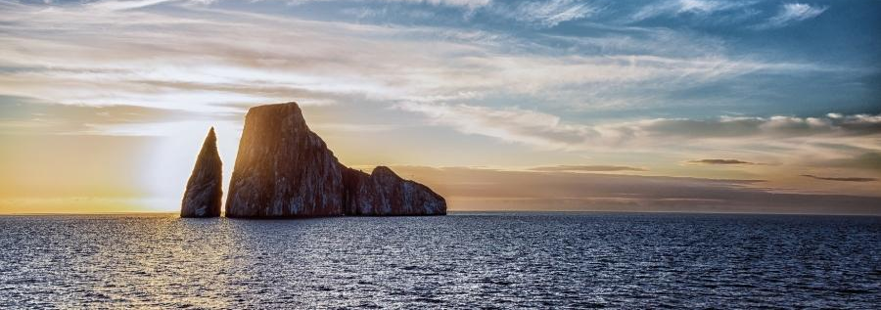
Highlights: Endemic plants, exhibition on human history
Trail | 0,2 km / 650 ft
Activities | Navigation around the Kicker Rock

After your morning exploration, it's time to say goodbye to the Galapagos Islands and transfer back to the Ecuador mainland. Reflect on the incredible experiences and the unique wildlife and landscapes you've encountered during your journey. The transfer to the airport is an opportunity to take in the last views of this enchanting archipelago.
This concludes your unforgettable exploration of the Galapagos Islands, a journey filled with natural wonders and wildlife encounters that will leave a lasting impression and a deeper appreciation for the delicate balance of our planet's ecosystems.
Glossary
Meals | Breakfast | B
Meals | Lunch | L
Meals | Dinner | D
Hiking Effort | Level 1 | Easy
Hiking Effort | Level 2 | Moderate
Hiking Effort | Level 3 | Hard

